\\ Khan Arman Riyaz

\\231P072,13

\\WAP: Write a program to implement Multithreading in java package Multithreading; public class Mythread1 extends Thread {

public static void main(String args[]) { Mythread1 ex=new Mythread1();

ex.create();

System.out.println("this is the main thread!");

}

public void create(){ Thread t=new Thread(this);

t.start();

}

public void run()

{

while(true) {

try {

System.out.println("this is the child thread!"); Thread.sleep(500); } catch (InterruptedException e) { }

} }

}

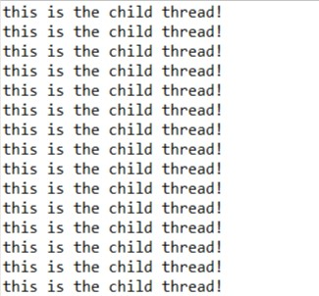

[\\ Khan](file:///\\Khan) Arman RIyaz

\\231P072,13

\\Write a program to print /\*/\*/\*/\*/\* using two child thread.

public class Mythread1 extends Thread {

public static void main(String args[]) { Mythread1 ex=new Mythread1();

ex.create();

System.out.println("this is the main thread!");

}

public void create(){ Thread t=new Thread(this);

t.start();

}

public void run()

{

while(true) {

try {

System.out.println(" /\*/\*/\*/\*/\*");

Thread.sleep(500); }

catch (InterruptedException e) { }

}

}

}

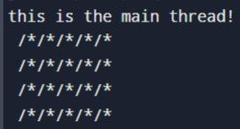

\\ Khan Arman RIyaz

\\ 231P072, 13

\\WAP: Write a program to print alphabets and numbers using two threads. public class ThreadsExample { public static void main(String[] args) {

Runnable r = new Runnable1();

Thread t = new Thread(r);

Runnable r2 = new Runnable2(); Thread t2 = new Thread(r2);

t.start(); t2.start();

}

}

class Runnable2 implements Runnable{ public void run(){

for(char i='a';i<='z';i++) {

System.out.print(i+",");

}

}

}

class Runnable1 implements Runnable{ public void run(){

for(int i=1;i<=26;i++) {

System.out.print(i+",");

}

}

}

